**Product Requirements**

*Book Recommendation System*

Team Know Nothings

# Brief problem statement

Now that mobile phones are ubiquitous, it has become easier and faster to snap pictures of things. However, using the phone’s camera to identify objects and query info about that object is still a work in progress.

To this end, we intend to demonstrate the convenience of using a mobile phone camera to identify an object and provide relevant results back to the user.

The user will take a picture of a book cover in the mobile application, automatically send the picture to a server-side web application to identify the ISBN using a trained artificial neural network of book covers, then retrieve the corresponding metadata from Google Books API. Finally, the web application will send the results back to the mobile app which will show the user various recommendations of similar books, movies and merchandise.

# System requirements

We will build an Android client mobile app using Android Studio on our personal computers. We will then train an Artificial Neural Network using the UNT HPC servers. Setup a function to call Google Books API. Finally, we will build a web application using Google Compute Cloud and Firebase.

# Users profile

This mobile application is targeted at every age level but will require basic understanding of how to take a picture using the client’s mobile phone and general understanding of using a mobile application. Our targeted audience are users that prefer to shop and look up info using a phone and more specifically a phone’s camera.

# List of Features

1. Capture picture of the book cover using mobile application
2. Identify ISBN using a web application based on the picture of the book cover
3. Query Google Books API for metadata about the book based on the ISBN
4. Retrieve a list of recommended books, movies and merchandise based on the metadata of the book

# Functional requirements (user stories)

List the Priority as 1 (High Priority - Critical) to 3 (Low Priority – Would be nice if we have time)

|  |  |  |  |
| --- | --- | --- | --- |
| **No.** | **User Story Name** | **Description** | **Priority** |
| R1 | Camera implementation | Use a camera to take a picture of a book cover | 2 |
| R2 | Database of recommendations | This is used to recommend other books based on a similar genre. | 1 |
| R3 | Addition of various other media | This could add other media ie movies, tv shows, merch based off of the book, etc. | 2 |
| R4 | Additional app (iOS) | If we have time afterwards, we could tie in an iOS app to the backend of our service. | 10 |

# Non-Functional Requirements

Security - make sure that user data is not able to be compromised

Reliability - make sure the service is up 24/7 and minimize bugs

Usability - make the GUI easy to understand

Cross Platform - we will attempt to create an iPhone app if there is extra time

Accuracy - make sure the recommendations make sense.

Fast Response Times – This app needs to produce results in shorter than 30 seconds.

Access To Data – 24/7 access to the app and its online services.

Sponsor Requirements

I have read and approved the material in this document. If there is no external sponsor, the TA or instructor will sign it for accuracy/scope.

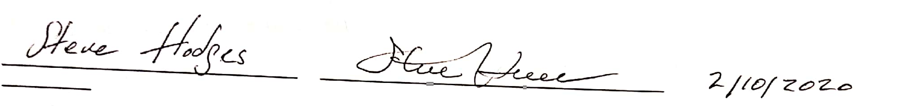

Print Name Signature Date